

RoboDex

OATIA’s Vehicle Anti Theft Expert Lookup System

Functional Specification Document

09-05-2012

**Document Management**

|  |  |
| --- | --- |
| Initiation Date | 0 12 September 2012 |
| Authors | Joseph PietrykowskiJ, Krishna Avatapally, Jacob Phillips, and Shazad Bakhsh |
| Key Contributors | Firas Assaad, Onkar Mahajan, Amrutha Pooja Muthyala, Anuroopa Reddy Vanteru, Xu Mingzhe, Changlong Chen, Rao Xu, Jizhou Tong |
| Concept Approver | Sean Rizor |
| Technical Approver | Dr. Henry Ledgard |

**Revision History**

|  |  |  |  |
| --- | --- | --- | --- |
| Rev. | Revision Date | Modified by | Descriptions of Revisions |
| B | 09/12/2012 | Authors* | Initial Version |

* Joseph Pietrykowski, Krishna Avatapally, Jacob Phillips, and Shazad Bakhsh

**Table of Contents**

Vision Statement...............................................................................................................3

1. Introduction.........................................................................................................................4

2. User Scenarios..................................................................................................................4

3. Process Flow.....................................................................................................................5

4. Functions............................................................................................................................6

5. Additional Screen Layouts.........................................................................................12

6. Database Description...................................................................................................15

7. Error Message/Notes...................................................................................................16

Vision Statement

Car Theft App

The purpose of the car theft app is to enable agency members in the field to quickly identify and contact specialists that can assist them in their current situation. It should do so quickly, intuitively, and with an elegant simplicity.

For example, an officer makes a routine traffic stop and notices that the vehicle’s VIN number seems to be tampered with. He or she may not be sure that something is amiss and want to talk to somebody who has specific training and experience with VIN numbers. The officer could simply pull out their cell phone, start the app, select the VIN number specialty, and press the call button. In essence, it would turn members in the field into specialists of whatever is necessary.

With all of the agency contacts and specialists only a phone call away, the efficiency of officers and other members in the field would be greatly enhanced. It would eliminate the need for calling someone at the station, asking them to find you someone that specializes in XYZ, and them scratching their head and replying “That’s a good question!” The efficiency savings reduces the time, cost, and stress associated with field work and increases effectiveness.

The main use case is exemplified above, but the app entails much more. Each member of the organization will have the ability to add and edit information within the app. This allows for information to always be up to date. Navigation of the app is simple and flexible. Members can search through lists to find the right contact according to specialty, agency, by name, or even by their position. A search function also allows searching through everything at once if desired. These features will allow the app to scale effortlessly.

1. Introduction

The users of this application are all police officers, investigators, detectives, insurance investigators, arson investigators, FBI, etc. In the field, these users often come across situations that they believe to be crimes. For instance, a VIN number that may have been tampered with to conceal a stolen vehicle. The issue is that it is not practical for these users to be experts in every aspect of auto-theft. This application will help by providing a lookup service for users so they may quickly identify and contact an expert in whatever crime they are currently investigating.

The purpose of the document is to convey project details to both technical and nontechnical readers. Developers shall reference this document as a development “road map” as well as the final deciding factor in disputes. The customer shall use this document in order to review the initial plan as well as observe and comment on any deviations from the initial design.The intent is to create a working document which will be updated with design change decisions throughout development.

2. User Scenarios

The following three scenarios are the work of Sean Rizor but have been included in this document as a reminder to the software developers of the customer’s vision.

**Scenario 1**:

Officer Jones stops a vehicle and through his investigation his senses are heightened to the point that something seems out of place with the vehicle identification plate on the vehicle. He thinks that it may have been tampered with, but he is not 100 percent sure, so he needs to make contact with someone who specializes in VIN plate tampering detection.

Officer Jones picks up his cell phone and brings up the auto theft app. He selects the list of categories of “Areas of Specialty.” Listed under “Areas of Specialty” is a specialty category called “Retag.” Officer Jones selects the specialty “Retag” and finds the name George Bush. Officer Jones selects George Bush and he now has a phone number that he can click on and it automatically calls George Bush.

If for some reason George Bush’s phone number is listed incorrectly, the officer has the ability to change the phone number to the correct phone number.

**Scenario 2**:

Officer Jones turns his investigation over to Detective Smith. Detective Smith notices a problem with the locking mechanism on the doors and the starting mechanism as well. Detective Smith decides that he needs to call a forensic locksmith, so he picks up his smartphone and brings up the auto theft app and selects “Areas of Specialty” and then selects “Forensic Locksmith” and finds Mark Ames listed. Detective Smith clicks on the phone number for Mark Ames and calls him for assistance.

If for some reason “Forensic Locksmith” is not listed as a category under “Areas of Specialty,” Detective Smith will have the ability to add the category and the contact name and phone number for Mark Ames.

**Scenario 3**:

Detective Smith knows that Mark Ames is a forensic locksmith, but he prefers to simplify his search. Smith will have the ability to click the search function and just type Mark Ames’ name and if the name is in the database, Mark’s name will come up for Detective Smith.

3. Process Flow

Yes

[www.OATIA.com](http://www.OATIA.com) / ROBODEX

No

Check your login name and password

Yes

Search:

By name

Not

Found

By Clicking “Agency Contact” Drop Down Menu:

Displays menu list and submenu list

Click one of the Submenu list: Shows details with edit, add and save options

Displays that particular person’s details

By Clicking “Area of Specialty” Drop Down Menu:

Displays menu list and submenu of the list

Log out

Main Page:

Area of Specialty Menu,

Agency contact Menu, Logout and Search option

Login Page

No

Click one of the Submenu list: Shows details with edit, add and save options

Figure 6. Webpage “sitemap” showing how to navigate between pages. Also note that all pages except “MEMBER LOGIN” and “REGISTRATION” will contain “search” and “Logout” buttons.

4. Functions

4.1 Member Login

The member login function will provide a way to secure the system against access and modification by unauthorized users. Only members that pay the $15 annual fee for OATIA shall be granted access. The user function should provide a warning to the user who is logging in if the user credentials are correct but the account has expired or if the account is within 2 weeks of expiration a reminder to pay the $15 fee will appear prior to logging in.

In order to login successfully, the user must provide correctly entered credentials, those credentials must be present in the member_id table, and the current date must be less than the expire_date field of the member_id table.

To reduce the level of required administration duties, consecutive failed login attempts will not lock a user account.

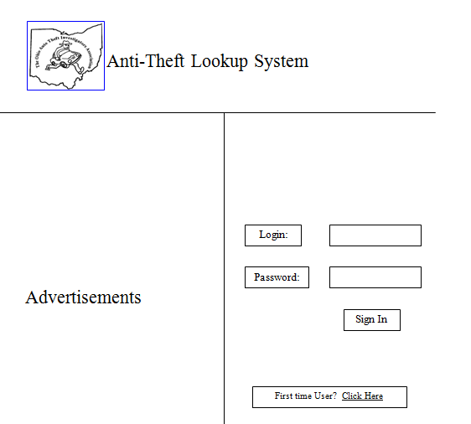

Figure 1. Member Login Page.

4.2 Registration

There shall be a button on the member login screen that provides a link to the OATIA website to facilitate registration. This application will use the pre existing registration and fee payment system already in place for the organization. This is the address for the existing OATIA registration page: <http://www.oatia.org/oatia_form.html>

**Developer Note:** User registration and payment systems are already in place for OATIA so there is no need to create a separate system. We will have to work with OATIA to figure out how to access their database to verify user credentials.

4.3 Display Selected Agency/Specialty Contacts

If the user wants to find a contact who works under an agency or is a specialist in an area, they will click the “Agency Contacts” or “Area of Specialty” buttons to bring up a drop down menu. They will then select an agency or area of specialty from the drop down list. Upon clicking an area of specialty or an agency from the drop down lists, they will be redirected to a page with the relative contact information. This page can be seen in Figure 2. If a user wants to edit a contact’s information, they will click the “Edit Contact” which appears in the row of the desired contact to be edited. This takes them to an “Edit Contact” page. If a contact has multiple phone numbers, agencies, locations, etc, they will all be displayed in the same cell on separate lines. For example see Sean Rizor’s Phone No. cell in figure 2. If a contact is missing information, for example an email address, the cell for that information and user will be left blank. An example of this can be seen for the Agency and Email columns for the, obviously made up contact, Bill Store.

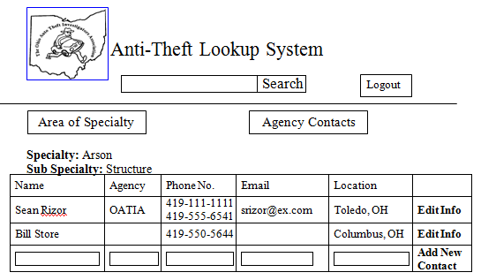

Figure 2. Display Contacts Page.

4.4 Add New Agency

Because there are a plethora of agencies for which contact information would be helpful we will include an “Add New Agency” function. This will keep RoboDex system administrators from having to manually add agencies each time a user requests.

To add a new agency, select the “Add Agency” option from the “Agency Contacts” drop down list. The user will be directed to a page containing a form prompting for the name of the new agency. The user will then click “Save” and the new agency will be saved in the database. Once created, the new agency will be an option under the “Agency Contacts” drop down list. It will then be possible to add new contacts for this agency. The server will maintain a log file with time stamped entries of the username and new agency name every time an agency is added.

New agencies will not be screened prior to being added to the database.

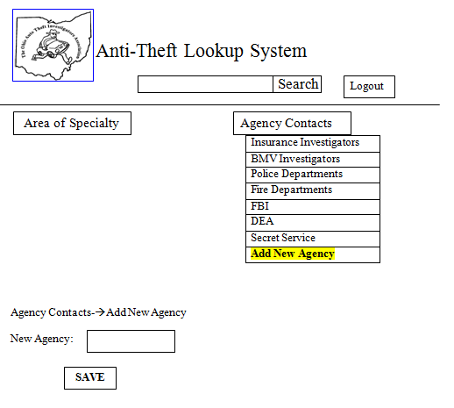

Figure 3. Add New Agency Page. Drop down menu showing how to navigate to this page is also shown.

4.5 Add New Contact

If the user wants to add a new contact they will first navigate to the “DISPLAY CONTACT INFORMATION PAGE” for the specialty or agency for which a new contact is desired. The “DISPLAY CONTACT INFORMATION PAGE” can be done opening the appropriate drop down menu, “Area of Specialty” and “Agency Contacts” drop down menus and selecting an specialty or agency. At the bottom of the table of contacts for that specialty or agency will be a table row with forms for information and an “Add New Contact” button. If valid data for the name, specialty, email, phone number, etc. for the new contact is entered then the “Add New Contact” button will save this information in the database. Once created, the contact will appear under the desired agency or specialty for which they were created. The server will maintain a log file with time stamped entries of the username and new contact information every time a contact is added.

The “Add New Contact” button and corresponding blank fields can be viewed at the bottom of the table depicted in Figure 2.

It is assumed that the users are mature, responsible, and competent. As such, new contacts will not be screened by an administrator prior to being added to the database.

The add new contact page shall display text listing suggested specialties, however any specialty shall be acceptable except "null" specialty. The suggested specialty list shall include:

Arson Investigator

Sub categories:

*Structure*

*Vehicle*

*Dog*

Cargo Theft

VIN Identification

Vehicle Registration

Heavy Equipment Identification

Social Networking

Title Laws

Salvage Dealer Laws

Scrap Metal Processor Laws

Attorney

Cell Phone Technology

Courts

Cloned Vehicles

Forgery

(This list of categories is not complete, but merely a sample categories.)

4.6 Edit Contact

The rightmost column of the table depicted in figure 2 will contain an edit contact button for each contact of an agency or specialty. Pressing this button will direct the page depicted in figure 4. The user can update a contact and select “Save” or delete a contact with “Delete Contact” just as one would assume. The server will maintain a text log file containing a time stamped message every time a contact is edited or deleted. Information stored will be contacts old information and new information as well as the username of the user who made the changes.

Deleted contacts will be flagged in the database as deleted but their information will not be removed in case of an accident or malicious break in. There will not be an undo button however so a system administrator must undo any accidental changes. When the delete contact function is activated, the webpage will also require a reason for deletion to be entered into a text box. The delete contact page should give example reasons for deletion such as retirement. Every time a contact is edited or deleted, a server log will also be kept with a time stamp, user who submitted the changes, and a complete copy of edited contact information before and after changes. This will allow reconstruction of corrupted database information by an administrator if necessary.

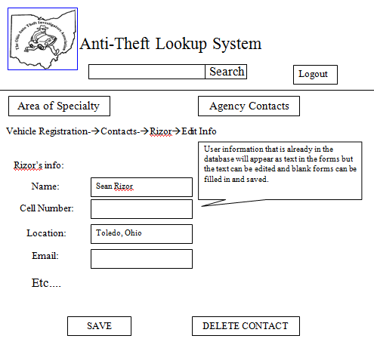

Figure 4. Edit Contact Page.

4.7 Search

On every page past the user login page there shall be a search text box and search submit button. This allows the user to search for an exact matching specialty or contact. For the first version of this software, fuzzy searches will not be implemented. Any search query submitted will automatically be run on contact names, specialties, agencies, and contact notes fields of the database. Results will be returned in the order of matching contact names first, followed by matching specialties, matching agencies, and contact notes with matching substrings.

**Nontechnical Reader Note:** Fuzzy searches will return results even if a word is not spelled exactly correct.

The search box can be seen below the title “Anti-Theft Lookup System” in figure 2, figure 3, and figure 4.

The webpage will have a button to sort alphabetically according to any of the table columns for a contact. In order to only view contacts in your area the user can just sort the zip code in ascending or descending order and choose a contact in the same, or a similar, zip code.

4.8 Links

This is really more of a feature than a function but a few links will be included on some of the specialty areas to make the system more useful. These links will not be editable by the user.

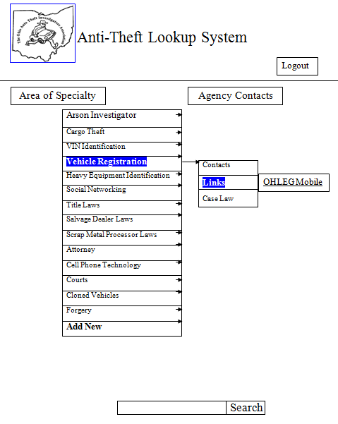

Figure 5. Example screenshot displaying suggested website links. Links will not be editable by users.

4.9 Logout

When the user is finished referencing or updating the Anti-Theft Lookup System they are encouraged to logout by clicking the “Logout” button. If a user does not logout manually, their session will eventually timeout anyway.

The “Logout” button can be seen in the top right corner of figures 2 through 5.

4.10 Suggested Future Functions

"Add to Favorites"

We believe that the utility of this application would increase if there were a way for members to add contacts to a favorites list for quick reference. To ensure the project does not go beyond the semester time limit this is a suggested future addition.

"Fuzzy Search"

A fuzzy search functionality would also increase the usefulness of this application. As it is highly unlikely that a user will be able to spell their search query exactly right every time we believe that implementing a fuzzy search function would be a worthwhile pursuit.

5. Additional Screen Layout

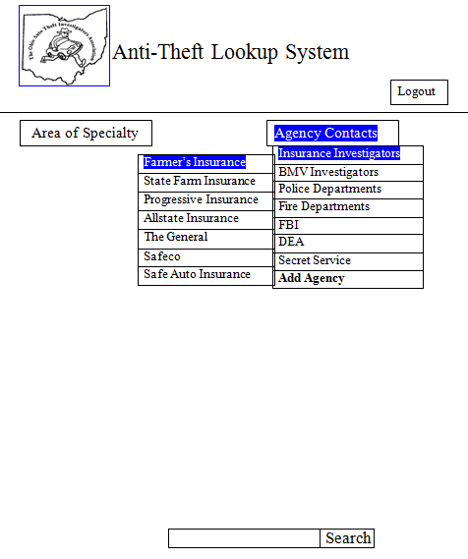

Figure 7. Example menu for insurance agent lookup.

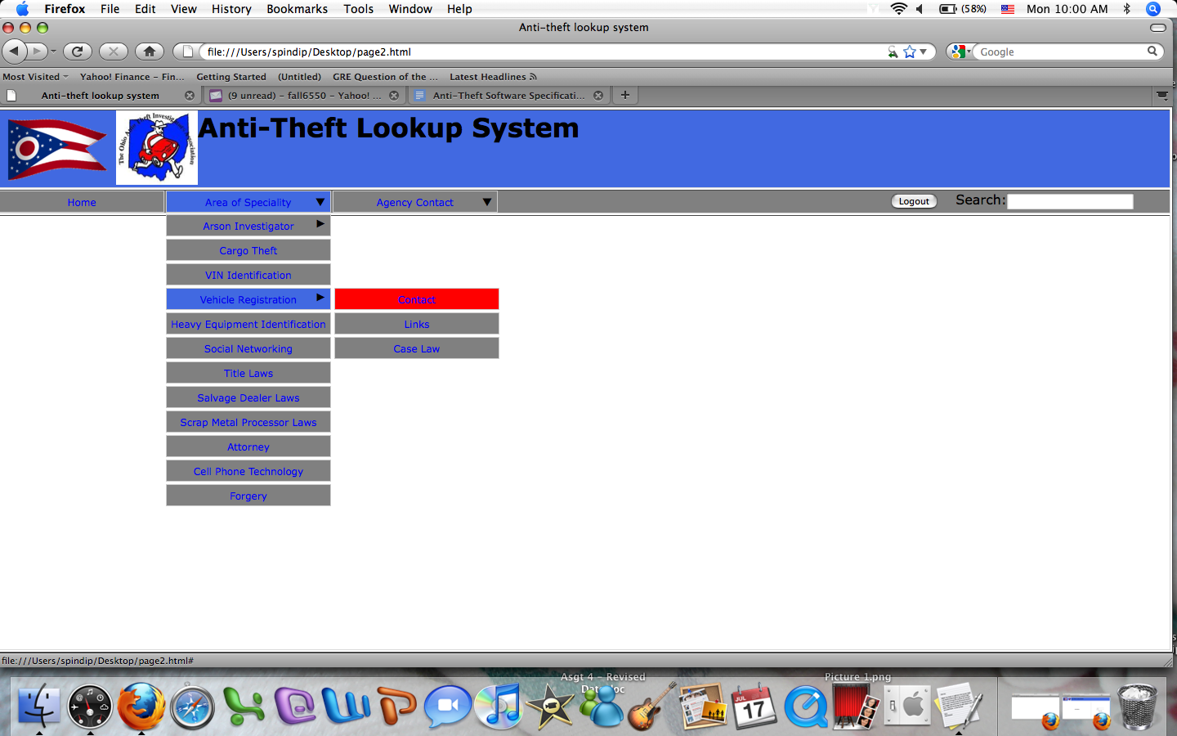

Figure 9. Sample of actual web page design depicting drop down menus.

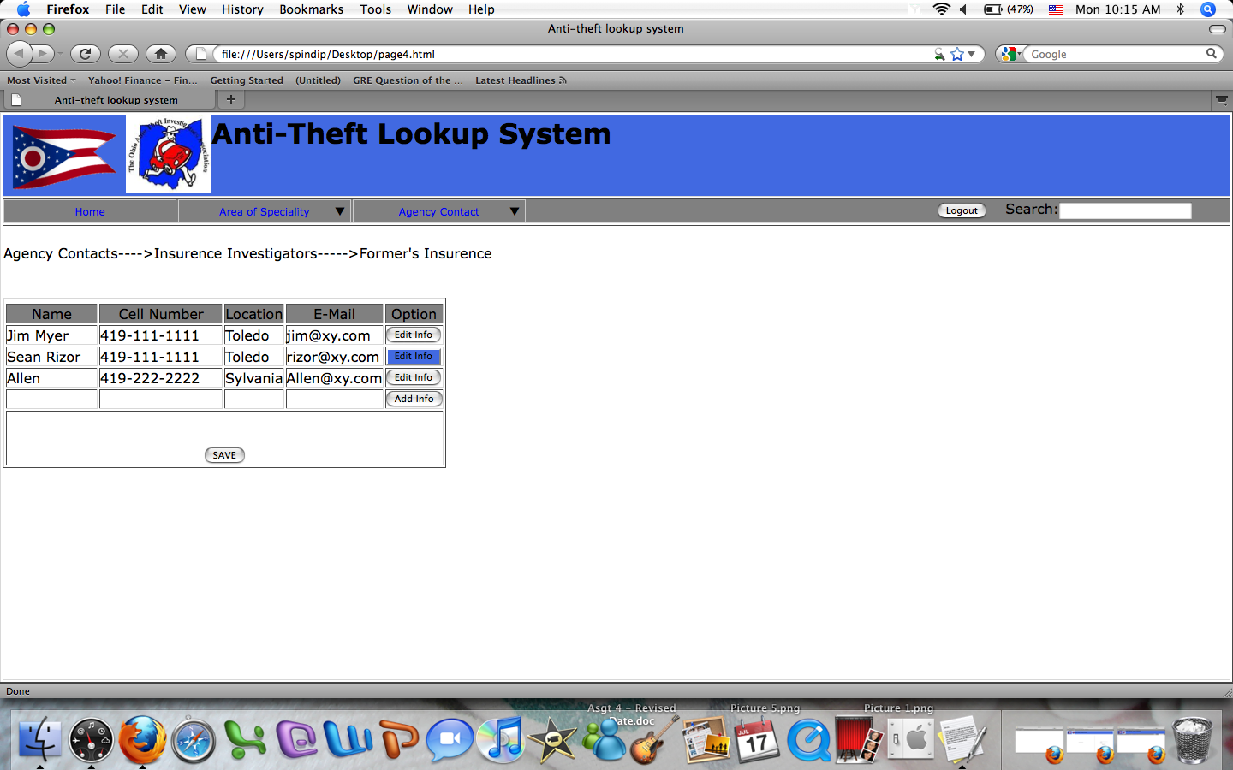

Figure 10. Sample of actual web page design depicting contact information.

6. Database Description

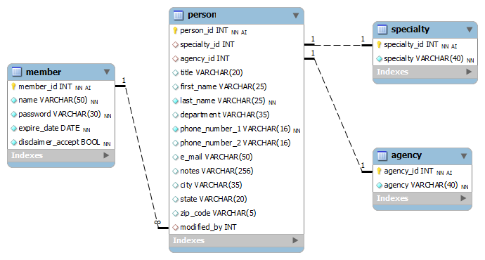

Figure 11. Database Tables.

The database will start out small at first with only a short list of contacts but even as the database grows, the disk space required is not anticipated to become a pressing issue. All information being stored will be in text form and the largest possible field is a varchar of 256 characters for the notes field. It is recommended that a script be created to back up all database information on a nightly basis (or during whatever time period where system usage is at a minimum).

**Specialty**

This table contains a list of specialties. Each specialty is given a unique value.

· **Specialty_id** - A unique number for each specialty. It is required (not NULL). It uses auto-increment.

· **Specialty** *-* This field will contain the specialties (auto theft, forgery, locks, etc.).

**Agency**

This table contains a list of agencies. Each agency is given a unique value.

· **Agency**_**id** *-* A unique number for each agency. It is required (not NULL). It uses auto-increment.

· **Agency** *-* This field will contain the agencies (insurance, etc.).

**Person**

This table contains the contact information for the specialist or agent. Only some of the fields are required(not NULL). A person is limited to 2 phones numbers (no extensions) and can have only one specialty and/or belong to one agency.

· **Person**_**id** *-* A unique number for each person. The primary key. Uses auto-increment. A required field.

· **Specialty**_**id** *-* A unique number for each specialty. A foreign key to specialty(specialty_id). Either this field or the agency_id field is required.

· **Agency**_**id** *-* A unique number for each agency. A foreign key to agency(agent_id). Either this field or the **specialty**_**id** field is required.

· **Title** *-* The persons title (Dect., Sgt., Mr., etc.).

· **First_name** - This is a required field.

· **Last_name** *-* This is a required field.

· **Department** *-* The department, office or company the person works for.

· **Phone**_**number_1** - The length of this field is based on a phone number like this: 1-(800)-555-1234. This is a required field.

· **Phone**_**number**_**2**

· **E***_***mail** – could be something like this: Mahalakshmi.Lakshminarayanan@rockets.utoledo.edu

· **Notes** *-* This field allows the member to add notes about the specialist.

· **City**

· **State** *-* The length of this field is based on: District of Columbia (not actually a state) = 20. Massachusetts = 13, Washington D.C. = 15

· **Zip**_**code** *-* The zip code is currently limited to 5 characters. It could be lengthened to allow 43560-1410. It is a VARCHAR field and not an INT.

· **Modified**_**by** *-* This field contains the member_id of the person who last modified this specialist’s information. It is meant to be used by the database administrator.

**Member**

This table contains the OATIA member information. OATIA already has a database of members, so there will need to be some integration of databases. All the fields in this table are required for each row (no NULL).

· **member***_***id** - A unique number for each member. Uses auto-increment.

· **username**

· **password**

· **expire**_**date** - The date that the members year of service ends. The default is set to today’s date. The DATE type is a standard database type.

· **disclaimer**_**accept** - Indicates whether or not the user has accepted the conditions for the use of the software, so that it doesn’t need to be displayed each time. The default is set to false.

7. Error Message/Notes

The following errors may occur and will result in the following error messages to be displayed to the customer.

**User Not Registered -** “The username you are trying to log in with is not registered for this service.”

This error page will feature a link to the OATIA registration page.

**Failed User Login -** “Incorrect Username or Password was provided.”

This error page will contain a username and password fields to attempt another login or a suggestion to follow a link to reset the user's password. Clicking the reset user password link will lead to a page prompting for an email address. If the email address matches a user in the database then a link will be sent out to the specified email. Clicking the unique link will send the user to a page where they can change their password.

In order to keep admin maintenance overhead low, user accounts will not be locked due to consecutive incorrect login attempts.

**Insufficient Information Provided for New Agency or New Contact -** The previously submitted form will be displayed again saying “Insufficient Information Provided for New Agency or New Contact.” All form data boxes which have invalid information will be highlighted with a suggested data format displayed below the box in question.